OPUS-Projects 12/29/2024
LAT: 37 06 47.51335 0.001 m 37 06 47.52475 0.001 m
W LON: 113 34 14.00904 0.001 m 113 34 14.06772 0.001 m
EL HGT: 896.018 m 0.001 m 895.263 m 0.001 m

Mark’s Notes from 2024:
L1 Offset of antenna: 120.32
896.018 + 0.120 = 896.138
This makes no sense.

The actual broadcast position is:
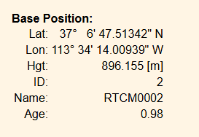
Is it really 1.7 cm high? Perhaps it matches TURN? Perhaps it was computed when installed and never updated. Could also the be the apply checkbox in the antenna screen.
I don’t dare change it at this point.

In Station
