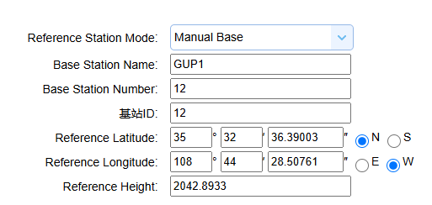
+ 0.1203 = 2042.8933
